✴

**Develop shared understanding and empathy**

Summarize the data you have gathered related to the people that are impacted by your work. It will help you generate ideas, prioritize features, or discuss decisions.

**Empathy map canvas**

# Use this framework to empathize with a customer, user, or any person who is affected by a team’s work.

Document and discuss your observations and note your

### What do they HEAR?

The government

**WHO are we empathizing with?**

Who is the person we want to understand? What is the situation they are in?

What is their role in the situation?

Overcoming the situation of hazard

To accommodate with steps

NGOs

### GOAL

**What do they THINK and FEEL?**

**PAINS**

**GAINS**

Guaranteed success rate

**What do they need to DO?**

What do they need to do differently? What job(s) do they want or need to get done? What decision(s) do they need to make?

Dynamic monitoring of the vulnerable areas

Effective Analysis of Disaster Impact

How will we know they were successful?

Predicting Risk Factors

Better understanding of impacts

Quality assurance

# assumptions to gain more empathy

for the people you serve.

What are they hearing others say? What are they hearing from friends? What are they hearing from colleagues? What are they hearing second-hand?

What are their fears, frustrations, and anxieties?

What are their wants, needs, hopes, and dreams?

Originally created by Dave Gray at

Community- friendly

Will this product be effective?

## 

Is it advantageous?

Unreliable performance

Uncertainty in analysis

Less Expensive and Reliable Product

Transparency in Data gathering and sharing

Lack of Proper Financial

What other thoughts and feelings might influence their behavior?

|  |  |
| --- | --- |
| Improved Chances Of Disaster Risk Prediction | |
|  |  |
| Usage of New and Emerging Technology | |

### What do they SEE?

Better pricing

Inefficient Data and Information Handling

What do they see in the marketplace? What do they see in their immediate environment? What do they see others saying and doing?

What are they watching and reading?

### What do they SAY?

What have we heard them say? What can we magine them saying?

## 

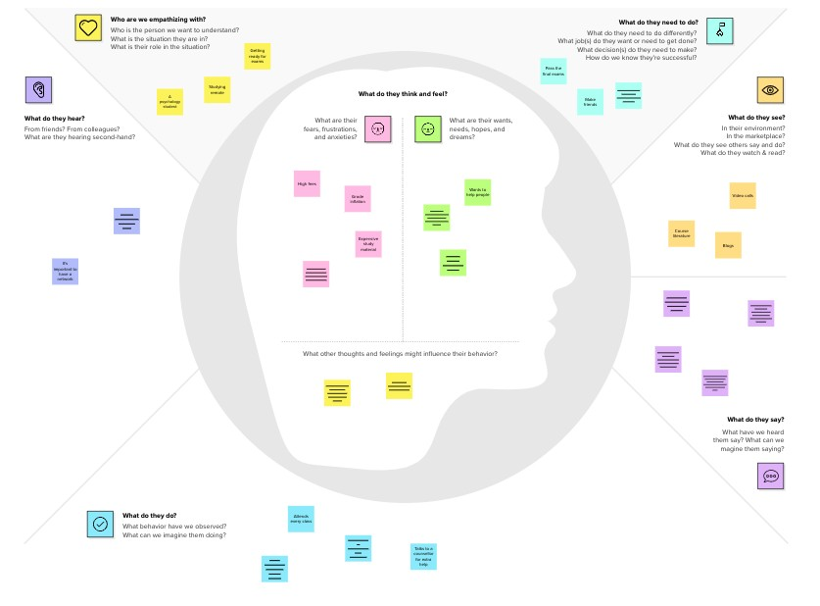

Do the outcome is better than the existing one?

**Template**

Can the project be practical?

Mental health

Expectations that the problem is worse

Minimizing loss of resources

Reducing human life risks

Economical backgrounds

Co-ordination of the people

On time output deliverables

Attempts to maximize the efficiency of the output

Effective analysis

### What do they DO?

Alerts the community

Collect the information about the area

What do they do today?

Gather the required data and analyzing it

What behavior have we observed? What can we imagine them doing?

[**Share template feedback**](https://muralco.typeform.com/to/CiqaHVat?typeform-source=app.mural.co)

**Need some inspiration?**

See a finished version of this template to kickstart your work.

[**Open example**](https://app.mural.co/template/018339d6-ff71-42d8-9e5c-abddde77d5ab/982236e0-c7e5-4fb6-83e9-ef1b972b25bd)